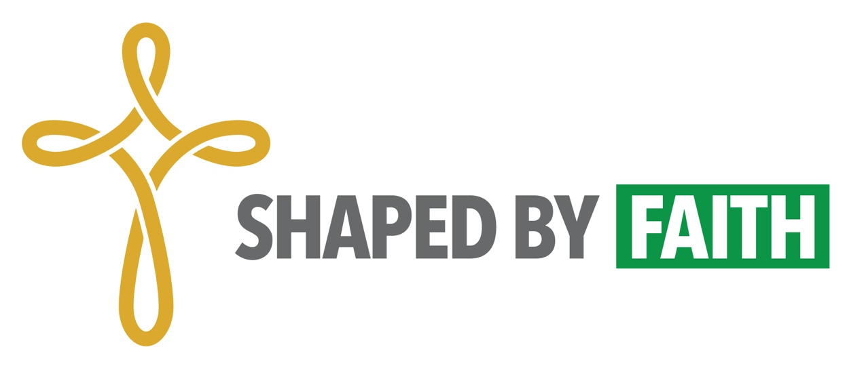

Assessment for Action Exercise
Please complete & submit by September 1
Note: Only 1 submission is needed from each parish

- Review the Church Models Slide (included as .ppt and .pdf)
For each of the models, please:
Name potential benefits and drawbacks.
Answer: Could our parish consider this model/configuration? Why or why not?

- Merger & Closer
Benefits:

Drawbacks:

Could our parish consider this model/configuration? Why or why not?

- Yoked Congregations
Benefits:

Drawbacks:

Could our parish consider this model/configuration? Why or why not?

- Minster Model
Benefits:

Drawbacks:

Could our parish consider this model/configuration? Why or why not?

- Multi-Site
Benefits:

Drawbacks:

Could our parish consider this model/configuration? Why or why not?

- Non-Profit Partnership
Benefits:

Drawbacks:

Could our parish consider this model/configuration? Why or why not?

- Ecumenical Partnership
Benefits:

Drawbacks:

Could our parish consider this model/configuration? Why or why not?

- House Church
Benefits:

Drawbacks:

Could our parish consider this model/configuration? Why or why not?

- Virtual Church
Benefits:

Drawbacks:

Could our parish consider this model/configuration? Why or why not?

- Financial Vitality Worksheet
Spend time exploring the financial vitality worksheet provided for your parish. Note any trends and discuss with members of your team. In consultation with other leaders in your parish (i.e. treasurer/property team), begin estimating projected capital expenses over the next 10 years.

If you have any questions about this tool or the figures included, please reach out to Canon Chad Linder (clinder@diocesecpa.org).

- Narrative Invitation Exercise
Drawing on the values and areas of vitality harvested through the Values Matrix and Church Behavior survey, compose a short paragraph (no more than 500 words) introducing your parish to potential collaborators. What is unique to your parish’s identity? What is worship like in your place? What areas of strength and vitality do you bring to possible ministry partners? What areas of strength and vitality might you be seeking from others?

