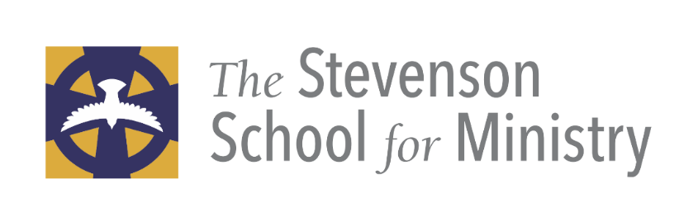

A learning community forming lay and ordained leadership for the Church of today and for the future.

Collaborative Mission Center—on line learning opportunities;
Certificate Programs and Shaped by Faith Courses

SSFM Course suggestions for In Collaboration with;
- Parish Life, ELCA Lower Susquehanna Synod
- Continuing Education and Diocese of Bethlehem
- Lay vocational certification Diocese of Pittsburgh

For more information visit www.diocesecpa.org or
Contact, Dean Robyn Szoke-Coolidge rszoke@diocesecpa.org (cell) 717-315-8088 (Cell)
Contact, Director Deacon Marsha Roscoe, Director of the Collaborative Mission Center -Lower Susquehanna Synod-ELCA

A Word of Welcome and Introduction

Introduction

The Board of Directors, Canon David Lovelace, chair, and the faculty and Dean of The Stevenson School for Ministry, welcome you. Your vocational discernment, education and formation process is very important to us.

The Diocese of Central PA’s Commission on Ministry, Standing Committee along with our Bishop, work together to provide effective ways for your leadership development and growth in faith. We are here to provide support, encouragement and challenge. The Stevenson School for Ministry is a place where scholarship, worship, theological reflection and practice of ministry are all integrated to shape your response to God’s call for you to be Gospel bearers in your context and culture. You are on an amazing journey with others who are strengthening the foundations of their baptismal faith and leadership.

Our motto is simple: faith formation for where people are to lead the church to where it is called to be. Our goal is a simple one, to equip leaders to Love and Serve Christ more deeply and to bring others to love and serve Christ and join God’s mission through the Jesus Movement and discover how the world is in God.

St. Paul said it best in his letter to the Ephesians:

But speaking the truth in love, we must grow up in every way into him who is the head, into Christ, from whom the whole body, joined and knit together by every ligament with which it is equipped, as each part is working properly, promotes the body’s growth in building itself up in love”
Ephesians 4:11-16

Our curriculum structure and our formation process not only immerse you in scripture, reason and tradition, our faculty incorporates the best insights and methodologies of the modern and post-modern world. We welcome all who feel called by God to join our hybrid (online and face to face) formation community. Please contact our Dean, The Very Rev. Robyn Szoke-Coolidge, with questions, email: rszoke@diocesecpa.org or call 717-236-5959 x1112

Certification Requirements Lay CANON 4 Licensed Ministries

We hold the Baptismal covenant to be the most concise expression of our relationship with God and one another and strive to live into it fully, with God’s help. Living out our Baptismal Covenant in specific ways: We believe that wrestling with your whole self is essential to deeper understanding of faith; your past, your perspective, your relationship to God, your passions, are where you are drawn to serve God. We'll walk with you on this journey.

Options for Lay Ministry: A Licensed Lay Ministry certificate program

CANON 4: OF LICENSED MINISTRIES
Sec. 1(a) A confirmed communicant in good standing, or, in extraordinary circumstances, subject to guidelines established by the Bishop, a communicant in good standing, may be licensed by the Ecclesiastical Authority to serve as Pastoral Leader, Worship Leader, Preacher, Eucharistic Minister, Eucharistic Visitor, or Catechist. Requirements and guidelines for the selection, training, continuing education, and deployment of such persons, and the duration of licenses shall be established by the Bishop in consultation with the Commission on Ministry.
Sec. 2(a) The Member of the Clergy or other leader exercising oversight of the congregation or other community of faith may request the Ecclesiastical Authority with jurisdiction to license persons within that congregation or other community of faith to exercise such ministries. The license shall be issued for a period of time to be determined under Canon II.4.1(a) and may be renewed. The license may be revoked by the Ecclesiastical Authority upon request of or upon notice to the Member of the Clergy or other leader exercising oversight of the congregation or other community of faith.
Sec. 2(b) In renewing the license, the Ecclesiastical Authority shall consider the performance of the ministry by the person licensed, continuing education in the licensed area, and the endorsement of the Member of the Clergy or other leader exercising oversight of the congregation or other community of faith in which the person is serving.

Pre- requisite: Safeguarding God’s Children, and Safeguarding God’s People

Safeguarding God’s Children and People and Becoming the Beloved Community are
pre-requisites.

Worship Leader
A lay person who regularly leads public worship under the direction of the Member of Clergy or other leader exercising oversight of the congregation or other community of faith.

Courses requirements: suggested as a foundational course--Anglican Approaches to Ministry
- Intro Hebrew Scripture I,
- Intro to the New Testament;
- Prayer Book Studies I, worship leadership (Morning and Evening Prayer Practicum offered during Learning Weekends 2020)
- Continuing education in Scripture study and completing Becoming the Beloved Community
- Must have up to date certificate in Safeguarding God’s Children

Suggestion: Spiritual Practices and Synoptic Gospels

Lay Preacher
A lay preacher is to be trained, examined, and found competent in the Holy Scriptures, the BCP and The Hymnal, the conduct of public worship, use of the voice, church history, Christian ethics and moral theology, the church's doctrine as set forth in the creeds and An Outline of the Faith (BCP, pp. 845-862), and homiletics. A licensed lay preacher is to preach only upon the initiative and under the supervision of the member of the clergy in charge.
Courses requirements: suggested as a foundational course--Anglican Approaches to Ministry
- Intro Hebrew Scripture I,
- Intro to the New Testament;
- Prayer Book Studies I, worship leadership (Morning and Evening Prayer Practicum offered during Learning Weekends 2020)
- Homiletics I for Lay preacher certificate
- Continuing education in Scripture study and completing Becoming the Beloved Community
- Must have up to date certificate in Safeguarding God’s Children

Suggestion: Spiritual Practices and Synoptic Gospels

A Eucharistic Minister is a lay person authorized to administer the Consecrated Elements at a Celebration of Holy Eucharist. A Eucharistic Minister should normally act under the direction of a Deacon, if any, or otherwise, the Member of the Clergy or other leader exercising oversight of the congregation or other community of faith.
Led and Developed by Archdeacon Jane Miron, contact deaconjane@comcast.net

A Eucharistic Visitor is a lay person authorized to take the Consecrated Elements in a timely manner following a Celebration of Holy Eucharist to members of the congregation who, by reason of illness or infirmity, were unable to be present at the Celebration. A Eucharistic Visitor should normally act under the direction of a Deacon, if any, or otherwise, the Member of the Clergy or other leader exercising oversight of the congregation or other community of faith.
Led and Developed by Archdeacon Jane Miron, contact deaconjane@comcast.net

A Lay Catechist is a lay person authorized to prepare persons for Baptism, Confirmation, Reception, and the Reaffirmation of Baptismal Vows, and shall function under the direction of the Member of the Clergy or other leader exercising oversight of the congregation or other community of faith.
Pre-requisite Courses:
- Intro to Hebrew Testament, Intro to New Testament
- Church History II: The Episcopal Church
- Prayer Book Studies I
- Chosen Modules for continuing education in The Certificate in Faith Formation for the 21st Century equips Christian leaders with the knowledge and skills, practices and approaches for faith formation; John Roberto vibrant faith Certificate in faith formation.
- Or Teaching Ministry SSFM Level I and Level II

Suggestion: Spiritual Practices: spiritual practices to develop a rule of life

Continuing education and competency in Safeguarding God’s Children and People and Becoming the Beloved Community.

John Roberto vibrant faith Certificate Courses:

One-year, three-part Foundations Program:

"Faith Formation for the 21st Century," provides the essential knowledge, practices, and skills for promoting lifelong faith growth and discipleship in the church community, at home, in age groups, and online.

"Faith Formation for the 21st Century," is offered over the span of one year, and covers three topics: 1) Reimagining Faith Formation for the 21st Century; 2) Designing Faith Formation for the 21st Century; and 3) Leading Faith Formation in the 21st Century. Each part of the course is 10 weeks in length (Winter: Jan-March, Spring: April-June, and Fall: Sept-Nov), with a break in the months of July and August. The fee for the Foundations Program is $750.
Students who successfully complete the Foundations Program along with SSFM courses in Scripture/Church History /Prayer Book studies will receive an SSFM certificate for Lay Catechist

LAY EVANGELIST:
Title III, Canon 4, Section 9
Evangelist - An Evangelist is a lay person who presents the good news of Jesus Christ in such a way that people are led to receive Christ as savior and follow Christ as Lord in the fellowship of the Church. An Evangelist assists with the community's ministry of evangelism in partnership with the presbyter or other leader exercising oversight of the congregation, or as directed by the bishop.

Certificate Programs through
The Collaborative Mission Center
Evangelism Certificate Program
On Line learning for strengthening ministry
The Stevenson School for Ministry and the Lower Susquehanna Synod invite you and/or your congregations’ participation in
Spring Term Feb 21-May 2nd, 2020
Fall Term August 21-October 24, 2020
Winter Term November 6, 2020-February 6, 2021
(Winter term break December 23 – January 4)

New Evangelism Certificate Program for Lay Evangelist Certificate; Instructors: Deacon Marsha Roscoe Director for Mission Interpretation Marsha Roscoe mroscoe@lss-elca.org (717) 652-1852, ext. 103 and Pastor Richard Jorgensen Director for Evangelical Mission for Congregational Renewal (717) 652-1852, ext. 105
Curriculum developed foundationally from The Way of Love and Becoming The Beloved Community and Evangelism Charter For the Episcopal Church

Courses; Reclaiming and Practicing Evangelism

Courses are available to individuals and parishes at no cost through Diocese of Central PA vouchers https://diocesecpa.org/shaped-by-faith-courses/

Foundations for Evangelism: Doing What Matters to God This five-week module uses Mark's gospel to explore the critical questions of "who?" and "why?" (more than "how?" and "what?") to better understand what it looks like to join Jesus in the Jesus Movement (five-week course). This course is pass/fail Registration Cost $150.00 or voucher.

Community Listening as Evangelism This five-week module explores the importance of understanding your community before implementing any evangelism strategies. Students will learn how to map their service/ministry area and neighborhood and learn how to and practice engaging community listening (five-week course). This course is pass/fail Registration Cost $150.00 or voucher.

Gospel Hospitality This five-week module teaches the basics of gospel hospitality: from signage, to welcoming space, to what happens when someone comes to the church for the first time. Students will learn how to examine their current context for intentional and unintentional gospel practices and inconsistencies (five-week course).
This course is pass/fail Registration Cost $150.00 or voucher.

Ways to Share our Story This 5-week module course explores how to seek, name and celebrate Jesus’ loving presence in the stories of all people. Students engage scripture and prayer practices that help us identify and name our own encounters with Jesus and that seek and name where we see the presence of Jesus in our communities and neighborhoods (five-week course). This course is pass/fail Registration Cost $75.00 per individual and $150.00 for two or more from the same congregation or voucher.
Ways to Pray; Spiritual Practices This five-week module course invites participants to explore in community one’s faith journey, noticing where we’ve been, where we are now, and where God is inviting us into, so we can grow in and bear witness to God’s Way of Love. Drawing from the deep roots of our Christian tradition, this course explores how spiritual practices shape our lives to follow Jesus (five-week course)

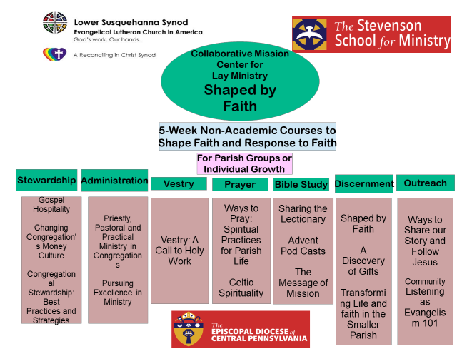
The Message of Mission Spring Term beginning the week of February 15th, 2021) This course explores how the apostolic witness to the gospel of Jesus Christ is at the heart of the church's mission. The church has the critically important task of communicating the message of Jesus Christ to the world. Reflecting on scripture and God's call for us, we use the Book of Acts as a model for contemporary ministry in the communities in which God has planted us (10-week course). Fall and Spring Term. This course will be graded. Registration Cost $300.00 or tuition assistance.

Additional Courses available through Shaped by Faith
To register for courses: https://diocesecpa.org/shaped-by-faith-courses/

