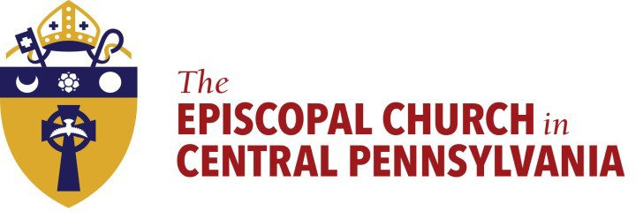

February 17, 2021
This cross is drawn from ashes blessed for Ash Wednesday.
Remember that you are dust, and to dust you shall return.

February 17, 2021
This cross is drawn from ashes blessed for Ash Wednesday.
Remember that you are dust, and to dust you shall return.

Almighty God,
you have created us out of the dust of the earth:
Grant that these ashes may be to us a sign of our mortality and penitence, that we may remember that it is only
by your gracious gift that
we are given everlasting life; through Jesus Christ our Savior. Amen.
BCP 265

Almighty God,
you have created us out of the dust of the earth:
Grant that these ashes may be to us a sign of our mortality and penitence, that we may remember that it is only
by your gracious gift that
we are given everlasting life; through Jesus Christ our Savior. Amen.
BCP 265

